QuArk Map Editor for Mahatta Tutorial

Quark Textures

With a map opened in Quark, open the texture browser. You can access the window by clicking on ‘Toolboxes’, then ‘Texture Browser…’.

Under ‘Texture Browser…’ menu, click on ‘Folders’ and then click on ‘New main folder…’. This will pop up another window ‘New Toolbox Folder…’.

Select ‘In a new Add-on’ and click ‘OK’.

Type in a name for the new file (ex: Ta-Ta Textures) and click ‘Save’. This will add a folder called ‘New Folder’. Scroll down till you see that folder:

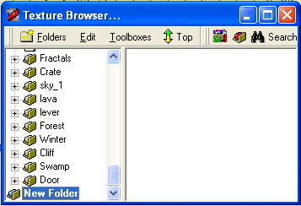

Click on the highlighted ‘New Folder’ once and rename it to however you want, preferably the same name as the file itself (ex: Ta-Ta Textures).

Under the new main folder, we want to create sub-folders to categorize all the textures for ease of selection.

You should carefully name the folders for textures, you want to categorize them based on their properties (like metallic textures should be in a folder ‘metal’; leaves, tree barks should be in the ‘nature or tree’ folder).

To create a sub-folder, with the new main folder highlighted, press ‘Ctrl+F’ or click on ‘Folders’ and then ‘New sub-folder’. You will then see a new sub folder called ‘New Folder’. You can create sub-folders within sub-folders as well.
To add a new texture under the highlighted folder, under ‘Texture Browser…’ click on ‘Edit’, then under ‘Import files’ you have two choices:

‘Import (copy) files…’ will copy the whole file inside the texture pack you created. This is convenient in a way that you can transport your work without worrying about putting the textures to their correct folder since the texture itself is inside the pack.

‘Make file links…’ will just copy the file path of the texture. This is convenient in a way that you save a lot of hard drive space, but transporting your work you’ll have to copy the textures to their correct folder. We will use this over ‘Import (copy) files…’ for fast project updating.
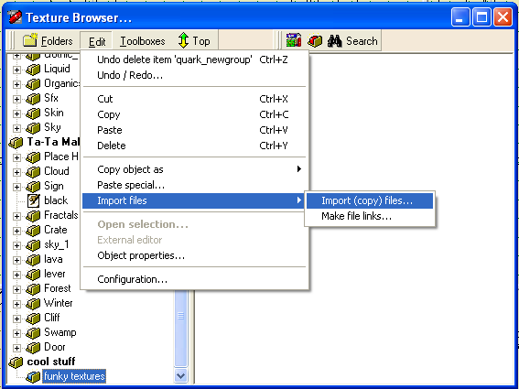

Click on any option, a new menu will pop-up where you have to select the file to import. You will want to select a texture file. Once you select a texture file, the texture will appear on the right side of the window and the texture name will be found under the highlighted folder. I recommend that you not rename the texture as this will affect level loading.

With the new texture, you can now use it on the geometry of the map.

To delete a texture, highlight the folder on which the texture resides. On the right side of the window, you’ll see a list of textures. Delete any highlighted texture from there by pressing ‘Delete’.

To add other texture pack: In ‘Texture Browser…’, click on ‘Folders’ then click on ‘Add-ons…’. This will pop up ‘Game Configuration’ menu. From here, you can remove and add map items for Quark editor to use. You can for instance select your newly created add-on and remove it from Quark.

To add a new add-on, simply click on ‘add’ and select from the list of add-ons to add. All of the custom add-ons are stored in the main Quark folder (eg: C:\QuArK\quark-win32-6.4.0alpha3\), you will also see your newly created add-on there once you save it.

